[DCO-2454] Motive Financial - Authenticated Signer Activation Multi factor authentication Created: 01/May/24 Updated: 06/May/24
Status: | In External Review
Project: | Journey Manager
Components: | None
Affects versions: | None
Fix versions: | Accessibility

Type: | Story | Priority: | None
Reporter: | Sanya Khandhuja | Assignee: | Fusi Olateru
Resolution: | Unresolved | Votes: | 0
Labels: | Motive, MotiveAuthenticated
Remaining Estimate: | Not Specified
Time Spent: | Not Specified
Original estimate: | Not Specified

Attachments: | image-20240501-132907.png
QA Bug Count: | 0
Days Open: | 5 days
Bug Count: | 0
Hours Variance: | 0
Hours Remaining: | 0
Hours Target PMO: | 0
Sprint:
Days Open: | 5

Description

When setting up two-factor authentication using the security question option, the
dropdown menu of security question options lacks a programmatically associated label.
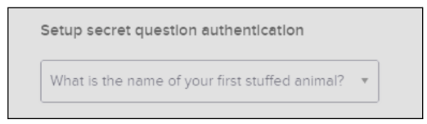
■ Recommendation: Ensure that each input field has a programmatically associated
label describing the field’s purpose. Use a <label> associated with the appropriate
field using a “for” attribute, ... or nest the <input> within the <label> ... or you could
instead use wai-aria (such as an aria-label or aria-labelled by) to provide a field label.

Comments

Comment by Fusi Olateru [ 03/May/24 ]
okta
Generated at Mon May 06 21:48:40 UTC 2024 by Ian Hicks using Jira 1001.0.0-SNAPSHOT#100252-rev:aa264b414382dcd2bbea0c3e63c78e358e7de0d5.

